The Instrumentino software platform, Version 3 (05/2015)
Instruction Manual

Written By:
- Joel Koenka
- Roland Fuiko

Description
Instrumentino is a graphical user interface (GUI) program, written in Python (version 2.7), which allows control of experimental settings, using controllers such as Arduino. It also includes a lean software package for the Arduino itself for the communication protocol (Controlino).

Motivation
The motivation to develop this program was to create an easy-to-use powerful way to control purpose made systems. Programming is not something that most people are comfortable with, so Instrumentino is built to minimize the programming efforts required, while giving a comfortable uniform way to control and run experiments. Python is well suited for that purpose, being a very popular high-end language, which is easily learned and for which plenty of online help exists in forums (just google – “how to do this and that using Python”).

Features
A single system dependent file describes system components (e.g. valves, pumps, pressure and voltage controllers) with their relevant system variables (e.g. valve state, plunger location, pressure, voltage and current) and basic actions, which change these variables in order to achieve something (e.g. flush interface, flush capillary, perform a HV separation); each action can receive parameters (such as pressure, time, voltage).

These actions can be then added in a list to create methods (can be saved as a .mtd files and loaded later), and saved methods can be added to a list to create sequences (can be saved as .seq files and loaded as well). A method or a sequence can be run by the user and stopped when needed, using the big STOP button. During each run, each action is logged to a file for future reference.

After initial connection to the relevant hardware controller (such as an Arduino), system variables are monitored and their values are periodically updated on the left panel, as well as graphically plotted in the log panel.

Requirements
In order to use Instrumentino, you should know Python to some extent and install some programs in order to create and run the project.
A short list of required software on your computer:
- Python 2.7
- pySerial
- wxPython (“agw” might be necessary as well)
- matplotlib
There are several ways of installing the necessary Python packages. The one I prefer is Enthought Canopy.
Canopy is a Python distribution that includes (among other things) a visual way to install python packages.
You need to register first with an academic email address and request an academic license (this takes only a few minutes to complete). Only then can you download the Canopy Full Installer from here. Please use the 32 bit version!
After installation is complete, you need some editor to write python code. Any text editor will do, though for advanced users, I’d recommend looking into the Eclipse IDE (Integrated Development Environment).

Install on Windows 7
Following are the steps for starting to use Instrumentino on Windows 7 (32bit or 64bit), using Canopy and Eclipse.
- Install Canopy.
- Open Canopy.
- Click on the “Package Manager”. You might need to login with the same username and password (upper right part of the screen). Use the package manager to install the following packages:
  - wxPython (this might already be installed)
  - pyserial
  - matplotlib
  - agw
- Open the terminal window (called “command prompt” in windows) and type:
C:\easy_install Instrumentino

- To check if everything worked fine, type:
C:\python to open the Python shell. This should look like that:
Enthought Canopy Python 2.7.6 | 32-bit | (default, Sep 15 2014, 17:34:02) [MSC v
.1500 32 bit (Intel)] on win32
Type "help", "copyright", "credits" or "license" for more information.
>>>
- In the Python shell, type:
>>> import instrumentino
If you got no error message, everything worked.

Install on Windows 7 (more detailed, in case the first version doesn’t work)
Following are the steps for starting to use Instrumentino on Windows 7 (32bit or 64bit), using Canopy and Eclipse.
- Install Canopy 1.5.1:
https://www.enthought.com/downloads/
This will install Python and some common packages in the computer. You need to register first with an academic email address and request an academic license (this takes only a few minutes to complete). Only then can you download the Canopy Full Installer, please use the 32 bit version.
To check if the installation was done properly, open a Terminal (cmd.exe) and type C:\python. Check that the Python version is 2.7.X, as Instrumentino was written using python 2.7
- Open Canopy 1.5.1 and uninstall the wxPython 2.8.10.1-7 package with the “Package Manager”. Further check the versions of the following packages:
  - Matplotlib 1.4.2-2
  - Pyserial 2.6-1
If the versions differ, the appropriate versions can be installed via the package manager, or downloaded at the according website.
- Download and install the wxPython 3.0.2 package for 32bit and Python 2.7
http://downloads.sourceforge.net/wxpython/wxPython3.0-win32-3.0.2.0-py27.exe
- To write and test your code, an IDE (Integrated Development Environment) would come in handy. A good free option is Eclipse:
http://www.eclipse.org/downloads/
Install the Eclipse IDE for Java EE Developers (LUNA 4.4.1)
Eclipse is an IDE that supports many programming languages, and the program became so big that the developers decided to release different versions of Eclipse. In order to develop Python programs in Eclipse, an additional plugin named PyDev (described next) is needed.
- Open Eclipse, and install PyDev. To install plugins in Eclipse:
  - Go to the Help menu and choose Install New Software.
  - Click the Add button and enter these details:
    - Name: PyDev (This doesn’t really matter)
    - Location: http://pydev.org/updates
  - Uncheck the 'Contact all update sites during install to find required software’, as
  - Tick everything in the window and continue according to the instructions. Agree when asked to trust the certificates.
  - Restart Eclipse
- A big advantage of Eclipse is the handling of the PYTHONPATH environment. If any errors occur during the install process of the packages mentioned above, start eclipse and navigate to: Window → Preference → Pydev → Interpreter Python menu. Here you have the possibility to change the path to the python interpreter and the installed packages. Usually the Eclipse IDE handle that for your needs. The result should look like the following:
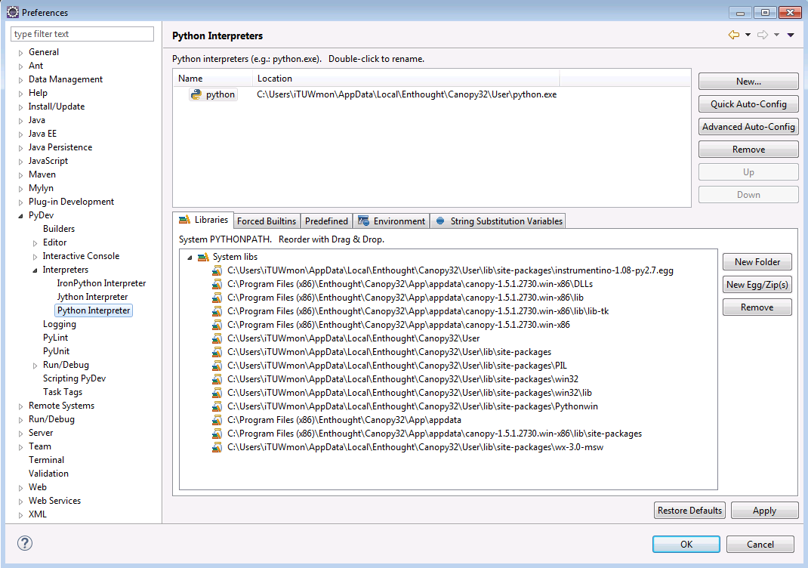

- Download Instrumentino https://github.com/yoelk/Instrumentino and unzip it.
- Install the Instrumentino framework egg by running the following command in the directory where it is stored (\Instrumentino-master\instrumentino\dist):
  - Start a command shell (cmd.exe)
  - Type in: C:\easy_install instrumentino-1.08-py2.7.egg (replace the filename if needed).
  - Test if it’s installed by running c:\python in the terminal and typing:
>>> import instrumentino
- Create a workspace directory for code projects e.g. Documents/workspace/Instruments/mySystem might be a good choice.
- Start Eclipse and a PyDev project. It should have one python file for the system description (e.g. mySystem.py). For an easy start, use a ready file from another system (e.g. supplementary material/example run (container.py)/container.py) and change it, according to your system’s requirements.
To run the code, open the file mySystem.py and while in PyDev view, choose the menu Run>Run. Alternatively, you can open a terminal, navigate to where mySystem.py is and type python mySystem.py

Install on gnu/Linux

Instructions are for debian derivatives such as Trisquel, Ubuntu and Raspbian (rasperry Pi OS). Instructions should be similar for redhat and derivatives (using yum-install) and other *ix operating systems.

Method 1

This installation method was tested on ubuntu 14.04 and 13.04 and should be applicable to any other linux distribution with little modifications.

A convenient way to install instrumentino on linux is to use anaconda and create a specific virtual environment for arduino / instrumentino.

Install anaconda by following the instruction at https://docs.continuum.io/anaconda/install
It calls for downloading and running a .sh file, and the installation should be straightforward.

Here are the detailed instructions.
Navigate to where instrumentino have been downloaded and unzip the .zip file.
Create the virtual environment:
conda create --name arduino python=2.7
Instrumentino requires python 2.7, not python 3.x, so it is important to create a virtual environment running python 2.7.

Activate the virtual environment:
source activate arduino
Note the prompt in the terminal should be preceded by (arduino).

From this virtual environment, we now install the dependencies required for instrumentino.
conda install pyserial
conda install matplotlib
conda install wxPython

Then run the setup.py setup file:
python setup.py install

A build directory is created.
But before one can run any instrumentino program, the arduino must be loaded with the program controlino (find it on git: https://github.com/yoelk/controlino/).
A way to do this is to open the arduino IDE, open controlino.cpp (or copy it in a blank sketch). Verify the compilation, it is possible an error arise from not finding the library PID_v1.h. IF so, download and install it (https://github.com/br3ttb/Arduino-PID-Library).
Edit the program in order to comment the line relevant to the board you are using, then upload controlino to your arduino board.

We are now ready to run instrumentino.

You can make sure the installation was successful by opening a python session, importing intrumentino and checking if all the ports on your computer are properly read.
Do so as follows:
python
import instrumentino
from instrumentino.util import SerialUtil
print SerialUtil().getSerialPortsList()

This will return a long list of ports, if the arduino is connected, it will be to one of them, such as ttyACM0 for example.

Let's now run one of the example which comes with instrumentino:

Navigate to /PATH/TO/instrumentino-master/documents/example_run_ArduinoPins.py/
and follow the instruction in section

Method 2

Open the terminal and run:

$ sudo apt-get install python-scipy python-numpy pyserial python-matplotlib python-wxglade arduino python-pip

A good scientific IDE is Spyder so it was added it is availble as part of the anaconda python distribution as well cross platform (windows, mac and gnu/linux). Anaconda is an alternative to Canopy. Also arduino was added just in case. Probably if you install python-scipy all the other packages such as matplotlib, numpy are installed. But just in case. Python-pip is a a variant to the easy install. The package

They we go ahead and install instrumentino. You could attempt

$ sudo pip install ez_setup

But if fails to install as it is missing ez_setup module so

$sudo pip install instrumentino

Check instalation by:

$ python
Python 2.7.6 (default, Jun 22 2015, 18:00:18)
[GCC 4.8.2] on linux2
Type "help", "copyright", "credits" or "license" for more information.
>>> import instrumentino

If no error is shown it seems to be all is installed and well.

To test it open spyder and run an example file if you have done

$ git clone https://github.com/yoelk/Instrumentino.git

it will be similar to this:

~/Instrumentino/documents/example_run_container.py/container.py

The window similar to the one seen on screenshots on the website seems to open but gives out the following warning.

/usr/lib/pymodules/python2.7/matplotlib/__init__.py:1173: UserWarning: This call to matplotlib.use() has no effect
because the backend has already been chosen;
matplotlib.use() must be called *before* pylab, matplotlib.pyplot,
or matplotlib.backends is imported for the first time.

warnings.warn(_use_error_msg)

Install on Mac OS
Following are the steps for starting to use Instrumentino on a Mac, using Canopy and Eclipse.
- Install Canopy:
To check if the installation was done properly, open a Terminal and type python. Check that the Python version is 2.7.X, as Instrumentino was written using python 2.7
- Open Canopy, and choose “Package manager”. Install the following packages: wxPython, matplotlib, pyserial
- To write and test your code, an IDE (Integrated Development Environment) would come in handy. A good free option is Eclipse:
http://www.eclipse.org/downloads/
Install either the Standard version or the Java version of the newest stable release. If it gives you error (from unidentified user) then go to system preferences and Tick window, which allows you to open Eclipse.
Eclipse is an IDE that supports many programming languages, and the program became so big that the developers decided to release different versions of Eclipse. In order to develop Python programs in Eclipse, an additional plugin named PyDev (described next) is needed. From my experience, this works for Eclipse versions supporting Java but not for Eclipse versions for C/C++.
- Open Eclipse, and install PyDev. To install plugins in Eclipse:
  - Go to the Help menu and choose Install New Software.
  - Click the Add button and enter these details:
    - Name: PyDev (This doesn’t really matter)
    - Location: http://pydev.org/updates
  - Uncheck the 'Contact all update sites during install to find required software’, as
  - Tick everything in the window and continue according to the instructions. Agree when asked to trust the certificates.
  - Restart Eclipse
- Install the Instrumentino framework egg by running the following command in the directory where it is stored (supplementary material/Instrumentino/dist):
easy_install instrumentino-1.0-py2.7.egg (replace the filename if needed).
Test if it’s installed by running python in the terminal and typing import instrumentino
- Create a workspace directory for code projects e.g. Documents/workspace/Instruments/mySystem might be a good choice.
- Start a PyDev project. It should have one python file for the system description (e.g. mySystem.py). For an easy start, use a ready file from another system (e.g. supplementary material/example run (container.py)/container.py) and change it, according to your system’s requirements.
- To run the code, open the file mySystem.py and while in PyDev view, choose the menu Run>Run. Alternatively, you can open a terminal, navigate to where mySystem.py is and type python mySystem.py

Troubleshooting and install hints:
- >>> import instrumentino throws an error containing “UltimateListCtrl” or something with “wxversion” then something is wrong with the wxPython installation. Try to remove every installed package of wxPython and run a registry cleaner. After that start Eclipse and navigate to: Window → Preference → Pydev → Interpreter Python menu. Check for any wxPython paths. If everything is clean, install the wxPython 3.0.2 package for 32bit and Python 2.7.
When the error wxversion occurs usually two versions of wxPython are installed. The “UltimateListCtrl” error comes with the wrong version of wxPython.
This problem may be also solved by using the Canopy package manager to install the package “agw” (version 0.9.1 is ok).
- Canopy Package Manager gives the error that no internet connection is available: Solution: logging out from and logging again in to your Canopy account. You can only be logged in on one machine!!
- C:\easy_install instrumentino-1.08-py2.7.egg went wrong:
Open Eclipse and navigate to: Window → Preference → Pydev → Interpreter Python menu. Remove all entries from PYTHONPATH environment variable and remove the Python interpreter (python27.exe). Add the interpreter again. The PYTHONPATH variables will be generated automatically. -> Try again.

The system description file
The system description file (e.g. mySystem.py) should include the following parts:
- imports
As in any Python file, it should begin with imports of other Python files it refers to (similar to include statements in C++).
It should at least include these imports:
  - from __future__ import division
  - from instrumentino import Instrument
  - from instrumentino import cfg
  - from instrumentino.action import SysAction
Import the necessary controller classes for your system. For example:
  - from instrumentino.controllers.arduino.parker import ParkerPressureController
  - from instrumentino.controllers.labsmith_eib.labsmith_comps import LabSmithValves4VM01
  - from instrumentino.controllers.labsmith_eib import SysVarDigitalLabSmith_AV201Position
  - Then, import the necessary parameters for the actions you’ll define later. For example:
  - from instrumentino.action import SysActionParamTime, SysActionParamFloat
- Systems constants
This may include Arduino pin assignments (e.g. pinAnalInParkerP = 5) or any other number which needs to be used in the rest of the code. It’s always good practice while coding to give meaningful names to numbers, so the code becomes readable and understandable.
- System components
This section describes the components in the system. Each component is represented by a Python class from the Instrumentino package. To check what hardware components are supported, browse the Instrumentino code and look in the path instrumentino/controllers/. There are some components already defined there, but if yours isn’t, you need to create it; this will not be covered in this manual.
As an example, here is a definition line for a Parker pressure controller:
pressureController = ParkerPressureController('Pressure', (0,100), pinAnalInParkerP, pinPwmOutParkerP, highFreqPWM=True)
The first given argument is the display name on the screen. The second is the allowed pressure range. The third and fourth are the input and output Arduino pins, used to control it. The fifth modifies the PWM frequency used for the analog output signal.
The order of these parameters can be checked in the Instrumentino code at instrumentino/controllers/arduino.parker.py
- System actions
This section lists the possible basic actions to be defined for the system. Here is an example for an action fills a container, using a pressure controller (see Instumentino release article):
class SysActionFillContainer(SysAction):
def __init__(self):
self.seconds = SysActionParamTime()
self.psi = SysActionParamFloat(pressureController.vars['P'])
SysAction.__init__(self, 'Fill Container', (self.seconds, self.psi))

def Command(self):
# Connect container to pressure controller
valves.vars['V1'].Set(valvePortPressure)
# Start pressure
pressureController.vars['P'].Set(self.psi.Get())

# Wait some time
cfg.Sleep(self.seconds.Get())

# Close container
valves.vars['V1'].Set('closed')
The action is defined as a class which inherits from SysAction (imported in the import section), and implements two necessary functions: __init__(self) and Command(self).
__init__(self) is an initialization function, in which the required parameters for this action are defined. In this example: a time parameter and a pressure parameter.
These parameters are then passed on to the parent class’s __init__ function, as arguments. Afterwards, when using the software, this is how it looks:
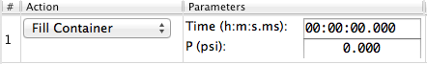
- System definition
In this section, the former components and actions are wrapped up by a single class called System, which inherits from instrumentino.Instrument.
Here is an example:
class System(Instrument):
def __init__(self):
comps = (pressureController, valves)
actions = (SysActionFillContainer(),
SysActionEmptyContainer())
name = 'Example System'
description = 'A container connected to a pressure controller'
version = '1.0'
Instrument.__init__(self, comps, actions, version, name, description)
As can be seen, the various components are given in a tuple to the variable comps, the actions to the variable actions, and the name, description and version string are defined as well. They’re all given to the __init__ function of instrumentino.Instrument in the appropriate order. Once this is defined, the Instrumentino framework will use this class to create the appropriate control program.
- Program run
This section shows how to make the python file runnable. The only thing needed is to initiate a System class, as defined in the last section. This starts the program.
if __name__ == '__main__':
# run the program
System()

Using the program
The program opens and waits for the relevant controllers to be connected through a serial port. At the moment, there is support for an Arduino (running the Controlino code) and a LabSmith EIB. Use the Comm menu to get the system online.
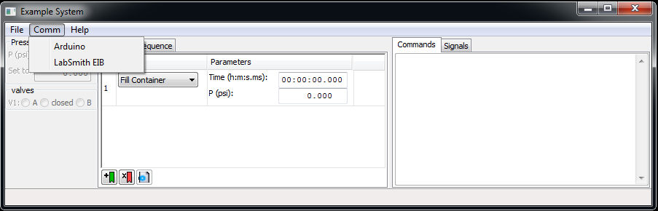

When the system is online, the system components’ pane is updated with values for the system variables and the signal log can be seen as well. Now it’s possible to run methods or scripts
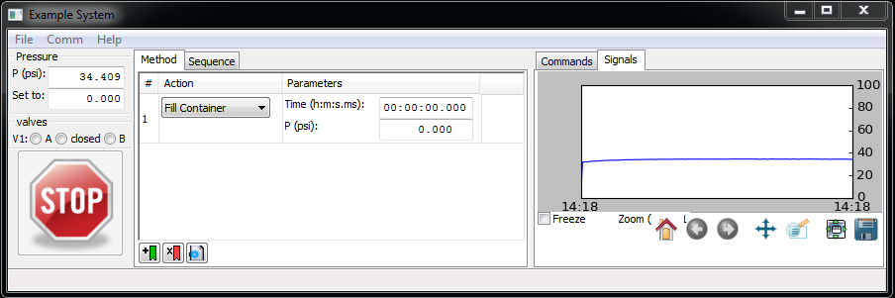

Use the File menu to save/load methods and sequences.

Running an example

This section describes how to test instrumentino's installation by running one of the example found in the /documents folder of the main instrumentino directory (the one which was created upon extracting the .zip archive).

We chose the example in:

documents/example_run_ArduinoPins.py/

It consists in sourcing a voltage on the pwm pins, low pass filtering it and reading it on the arduino analog pins. Only 2 resistors and 2 capacitors are required for the test.

Two 220k resistors and two 1uF capacitors are used.
Connect the arduino as follows:
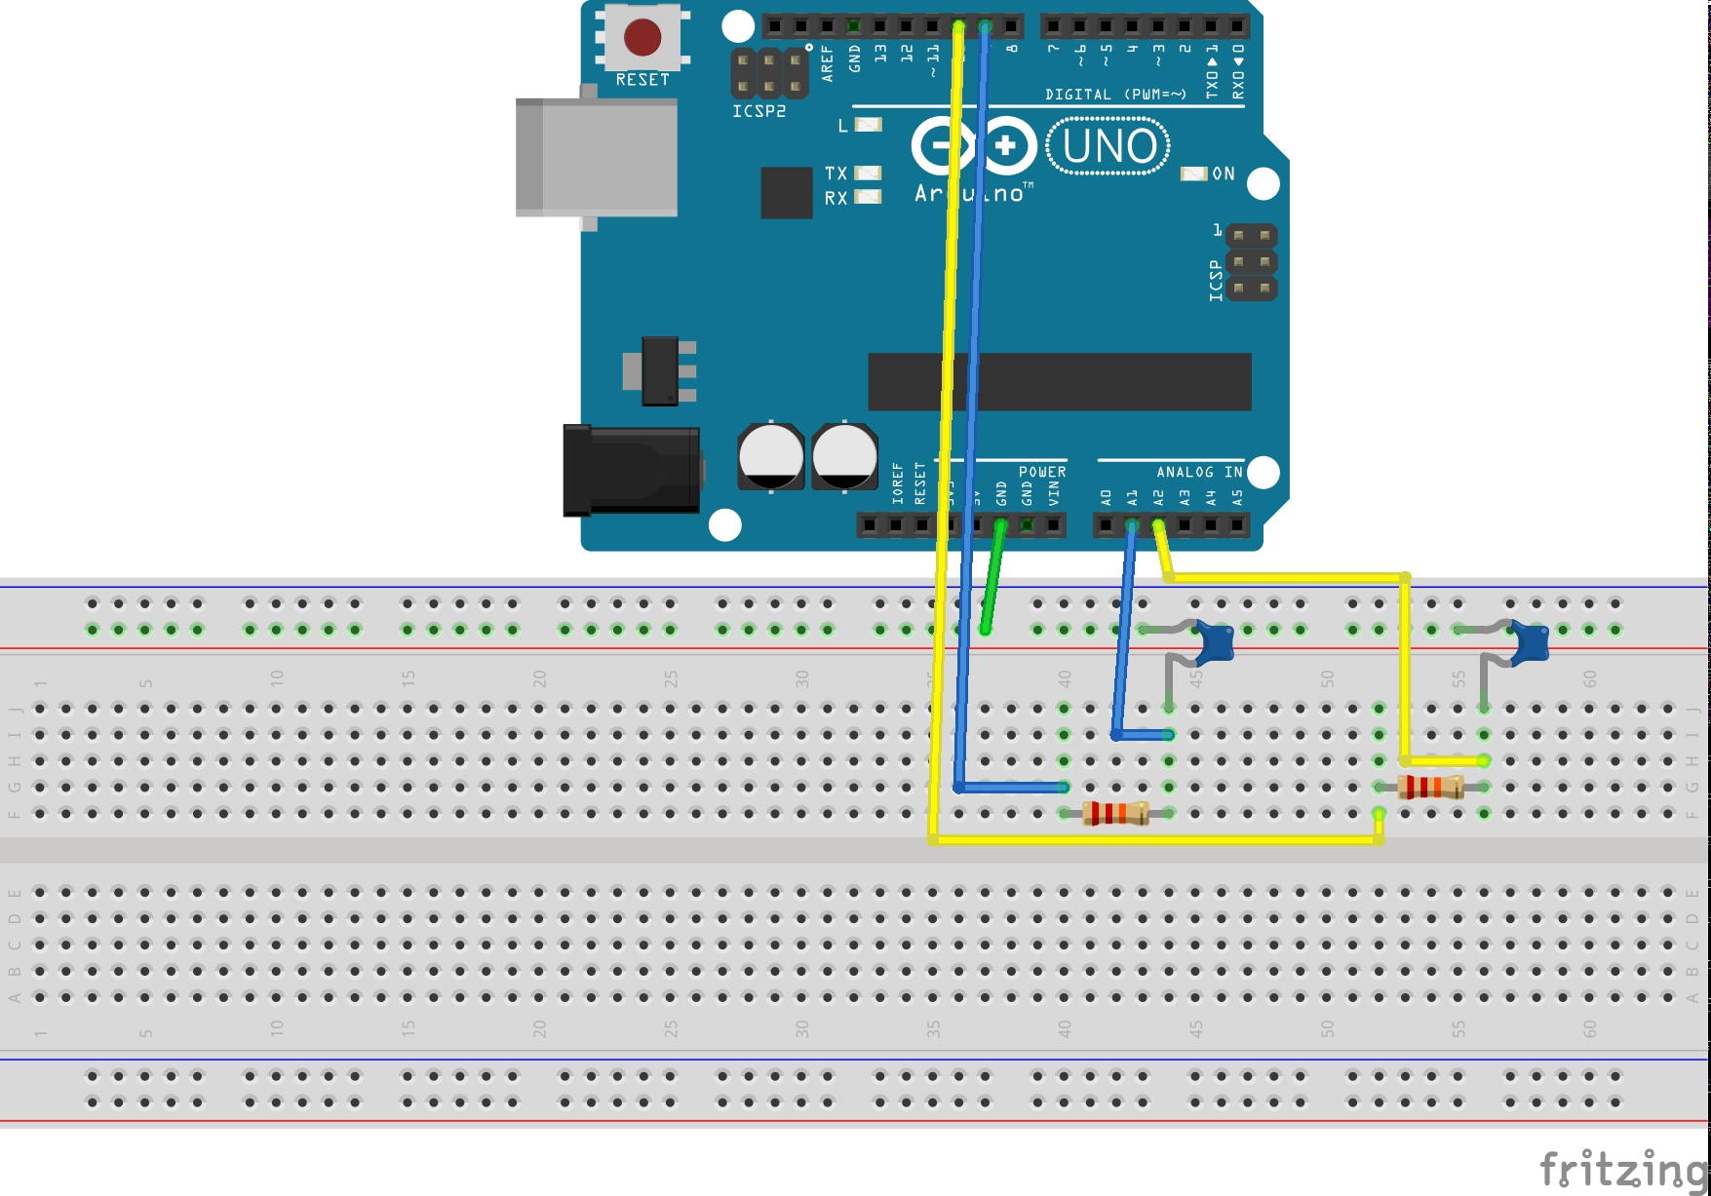
Photos, instructions for the arduino setup (components and connections) and even the original fritzing file are also included in the above folder.
Run the example:
python ArduinoPins.py

This will open the following GUI.
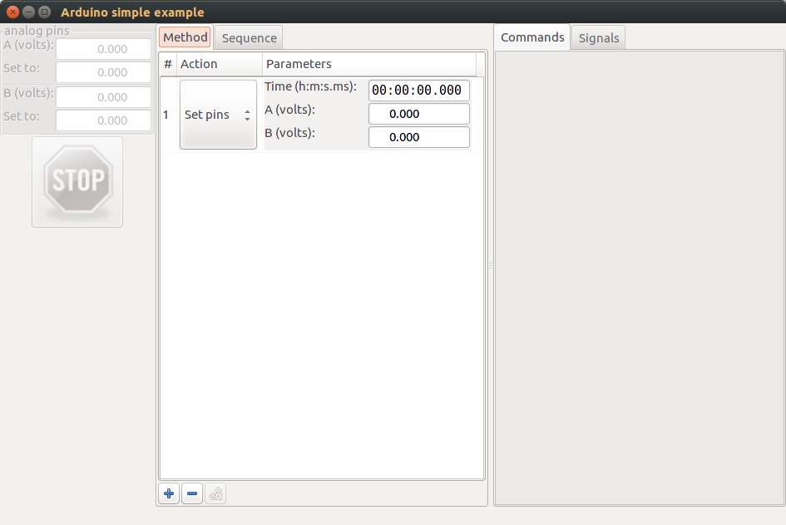
We now tell instrumentino which port the arduino is connected to: go to the menu comm → Arduino and select the port to which your arduino is connected.

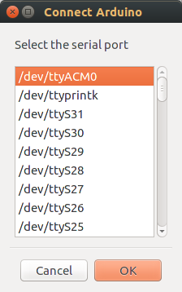

Swtich to the signal tab (on the right, next to “Commands”), and you will see a real time plot (for now there's no voltage set, so nothing to monitor, only time varies).

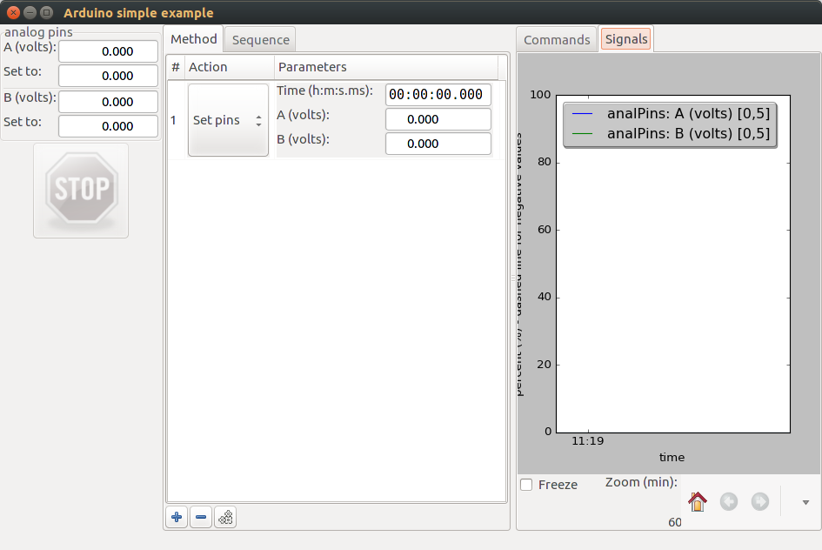
We now set the voltage on the PWM pins, in the dialog box “Set to:” above the STOP button. Enter a voltage for example 1V and press enter. You will see the value read on the analog pins varying and plotted.

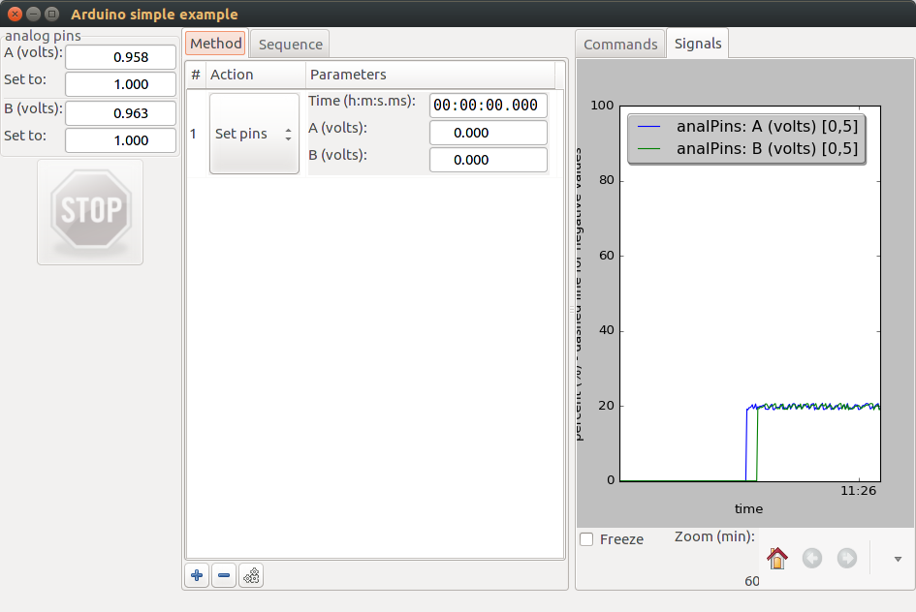

We now create a method. A method consists in action to be performed during a certain time. Here we'll set a voltage on either or both PWM pins, reading it and do so for a given duration.

Press the “run method” button right next to the “+” and “-” buttons. The method is executed for the specified duration. The STOP button is enabled and the method is executed (below I have executed 2 times and one is being executed). Stop the method by pressing the stop button.

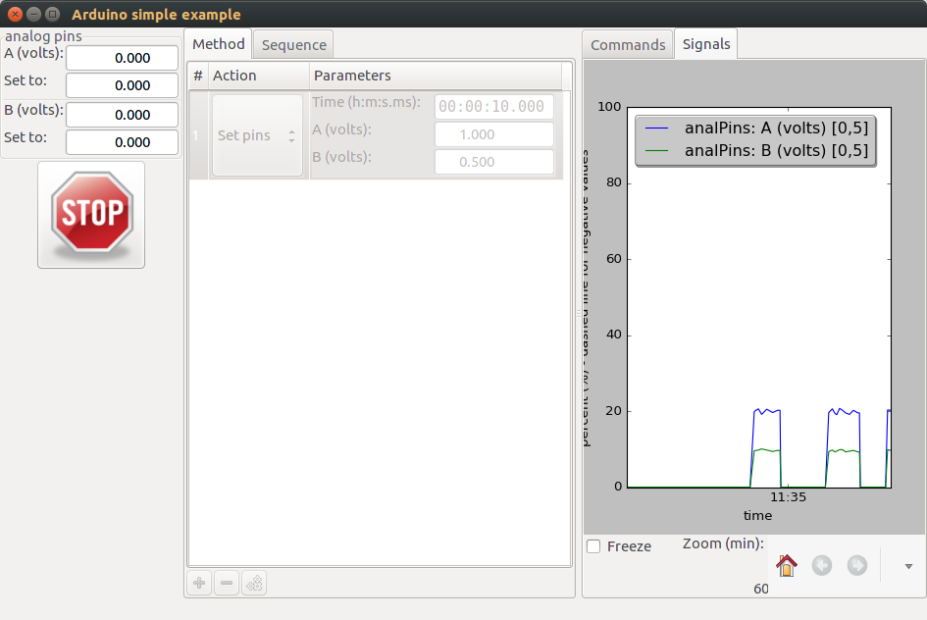

More actions can be added to a method (use the + button at the bottom). To delete an action, select it and use the – button.

The code for performing this test is simple, per the philosophy of instrumentino as designed by its author: you define the arduino pins, system components and actions to be taken.

A lot of methods have already been implemented, they can be surveyed in /PATH/TO/instrumentino-master/instrumentino/controllers/arduino/.
The __init__.py in the /documents/controllers folder defines several classes, such as the ones used in the example above, SysVarAnalogArduinoUnipolar and SysVarAnalogArduino.

Preparation of a stand-alone executable file (main.exe)
For extra reading about this process:
- http://www.pyinstaller.org/
- http://stackoverflow.com/questions/7674790/bundling-data-files-with-pyinstaller-onefile
- http://irwinkwan.com/2013/04/29/Python-executables-pyinstaller-and-a-48-hour-game-design-compo/

For Windows:
In order to make a stand-alone executable, to be transferred to another windows PC (which doesn’t have Python installed on it), it’s necessary to download PyInstaller:
http://www.pyinstaller.org/.
Download it to your PC, let’s say to C:\programs\pyinstaller-2.0\
Then, while in the directory of your system description file, type in the terminal:
C:\programs\pyinstaller-2.0\pyinstaller.py mySystem.py
This creates a new directory Instrumentino\dist\mySystem, in which there’s an executable file to run the program. Because of a bug in PyInstaller, it is necessary to copy the Instrumentino code to this directory.

